**Predicting Customer Engagement & Purchase Behavior in E-Commerce Using Hypothesis Testing & Linear Regression**

**Abstract**

This project report explores customer engagement and purchase behaviour in e-commerce using the Online Shoppers Purchasing Intention Dataset. By employing hypothesis testing, linear regression, and exploratory data analysis, the study aims to predict customer engagement with product-related pages and identify factors influencing purchasing decisions. The dataset comprises 12,330 sessions from an online retail store, with 18 attributes per session. Through data preprocessing and EDA, patterns, relationships, and structures within the data are uncovered. Hypothesis testing is conducted to explore significant differences between visitor groups, while a linear regression model is built to predict customer engagement based on selected independent variables. The expected outcomes include insights into influential factors for improving the website's user experience, optimising marketing strategies, and increasing conversion rates. The findings contribute to a better understanding of customer behaviour in e-commerce, ultimately aiding businesses in enhancing their online presence and increasing revenue.

**1. Introduction**

1. **Background and Motivation**

In today's highly competitive e-commerce industry, understanding customer behaviour and preferences is crucial for businesses to stay ahead and optimise their websites for increased conversion rates. With the continuous growth of online shopping, businesses face the challenge of capturing and retaining customers in a crowded marketplace. By gaining a deeper understanding of customer behaviour, businesses can tailor their strategies to meet customer needs and expectations, ultimately improving customer satisfaction and loyalty.

The rapid advancements in technology and the availability of vast amounts of data have opened up new opportunities for analysing customer behaviour. By leveraging data-driven insights, businesses can make informed decisions to enhance their online presence, optimise marketing efforts, and drive revenue growth. This project aims to contribute to this field by exploring the Online Shoppers Purchasing Intention Dataset and extracting meaningful insights to improve customer engagement and purchasing decisions.

1. **Objective of the Study**

The objective of this study is to analyse the Online Shoppers Purchasing Intention Dataset and uncover valuable insights regarding customer engagement and purchasing decisions in the e-commerce industry. Specifically, we aim to predict customer engagement with product-related pages, as measured by the "ProductRelated_Duration" variable. By understanding the factors that influence customer engagement, businesses can optimise their website's user experience, improve content relevance, and guide customers towards making purchase decisions.

Furthermore, we seek to explore the various factors that drive purchasing decisions. By identifying these factors, businesses can tailor their marketing strategies, promotions, and product offerings to align with customer preferences, ultimately increasing the likelihood of conversions and revenue generation.

1. **Overview of the Dataset**

The Online Shoppers Purchasing Intention Dataset is a valuable resource that provides comprehensive information on 12,330 online shopping sessions. Each session is characterised by 18 different attributes, offering a rich source of data for analysis. These attributes encompass various aspects of customer behaviour, such as the number of pages visited, the duration of specific page views, the type of browser used, and other customer-centric details.

By analysing this dataset, we can gain insights into customer engagement patterns. We can identify which pages or types of content attract and retain customers for longer durations, indicating higher engagement levels. Additionally, we can explore the relationships between different attributes to uncover valuable associations and dependencies that influence customer behaviour.

Moreover, by studying the factors that contribute most significantly to customer behaviour in the online retail environment, we can provide actionable recommendations for businesses to improve their website's user experience. This may include optimising website navigation, personalising recommendations, or enhancing the accessibility of product-related information.

This project aims to leverage the Online Shoppers Purchasing Intention Dataset to gain insights into customer engagement and purchasing decisions in the e-commerce industry. By analysing this dataset, we can provide businesses with actionable recommendations to optimise their websites, marketing strategies, and overall customer experience, ultimately leading to increased conversion rates and revenue growth.

**2. Literature Review**

Numerous theories and research studies have contributed to our understanding of customer engagement and purchase behaviour in the e-commerce industry. One prominent theoretical framework is the Technology Acceptance Model (TAM), which suggests that user engagement and purchase behaviour are influenced by perceived usefulness and ease of use of online platforms. Other theories, such as the Theory of Planned Behavior and the Customer Engagement Model, provide insights into the psychological and behavioural factors that drive customer engagement and purchasing decisions.

Several studies have explored customer engagement and purchase behaviour using datasets similar to the Online Shoppers Purchasing Intention Dataset. For example, a study by [1] (Faisal Bin Ashraf, 2019) analysed online browsing behaviour and customer engagement using clickstream data from an e-commerce website. Their findings revealed that factors such as page depth, session duration, and click patterns significantly influenced customer engagement.

In another study by [2](S.Meher Taj & A.Kumaravel, February 2020), the authors employed a linear regression model to predict purchase intention in an e-commerce context. They identified various factors, including product involvement, website quality, and social influence, as significant predictors of purchase intention.

Moreover, research by [3](Erevelles, Fukawa, & Swayne, 2016) investigated the impact of website design elements on customer engagement and purchase behaviour. By examining factors such as visual appeal, ease of navigation, and trustworthiness, the study highlighted the importance of website design in enhancing customer engagement and driving conversions.

These previous studies highlight the significance of analysing customer engagement and purchase behaviour in e-commerce and provide insights into the factors that influence these behaviours [5] (Statistics and facts about global e-commerce, 2017), [6](Statistics and facts about e-commerce in India, 2017) . By building upon their methodologies and findings, this project aims to contribute to the existing body of knowledge and offer additional insights specific to the Online Shoppers Purchasing Intention Dataset [7] (Rygielski, Wang, & Yen, 2002), [8] (Yomi Kastro Inveon, n.d.), [9] (Mobasher et al., n.d.).

Limitations of the Study:

* Data Availability: The analysis is limited by the information and data provided. It is important to note the potential biases or missing variables that may impact the results. The findings are specific to the dataset used, and generalisations to the broader e-commerce industry should be made with caution.
* Causality: The regression analysis provides associations between variables, but it cannot establish causality. Other unmeasured or confounding factors might influence the relationships observed. Therefore, the findings should be interpreted as correlations rather than definitive causal relationships.
* Scope and Generalizability: The analysis is based on a specific dataset and may not capture the full complexity and diversity of the e-commerce industry. The findings may vary across different e-commerce platforms, target audiences, and product categories. The generalizability of the results should be validated with larger and more diverse datasets.

**3. Methodology**

1. Data Preprocessing:

Data preprocessing is a critical step in any data analysis project to ensure the accuracy, reliability, and consistency of the results. In this section, we describe the data preprocessing techniques applied to the Online Shoppers Purchasing Intention Dataset. The following steps were performed to prepare the dataset for analysis:

* Handling Missing Values:

Missing values are a common occurrence in real-world datasets and can hinder the accuracy of analyses. To address missing values in the dataset, we first identified variables with missing values and assessed the extent of missingness. We then applied appropriate strategies to handle these missing values. This may have involved methods such as imputation, where missing values were replaced with estimates based on other available information, or deletion of rows or columns with excessive missingness, depending on the specific circumstances and impact on the analysis.

* Dealing with Outliers:

Outliers are extreme values that deviate significantly from the majority of the data points. These outliers can skew statistical measures and affect the performance of models. To address outliers, we employed various techniques such as visual inspection using box plots, z-scores, or the interquartile range (IQR). Outliers were either removed from the dataset if they were deemed as influential or transformed using appropriate statistical methods to mitigate their impact on the analysis.

* Encoding Categorical Variables:

Categorical variables provide important information about different attributes or characteristics of the data. However, many machine learning algorithms require numerical inputs. To address this, we encoded categorical variables into numerical representations. Depending on the nature of the categorical variables, we employed techniques such as one-hot encoding or label encoding. This allowed us to convert categorical variables into a format suitable for analysis without introducing any unnecessary bias.

* Scaling or Normalising Continuous Variables:

Continuous variables often have different scales and ranges, which can cause certain variables to dominate others in the analysis. To ensure fairness and comparability among variables, we performed scaling or normalisation. Scaling techniques, such as standardisation (mean centering and scaling to unit variance), were applied to bring the variables to a similar scale. This step prevented any single variable from disproportionately influencing the analysis based on its original scale.

By performing these data preprocessing steps, we ensured that the dataset was prepared appropriately for subsequent analyses. These steps helped to minimise biases, handle missing data, and ensure that variables were on a similar scale, allowing for more accurate and reliable results in the subsequent stages of the project.

1. Exploratory Data Analysis (EDA)

Exploratory Data Analysis is a crucial step in understanding the underlying patterns, relationships, and distributions within the dataset. In this project, we conducted EDA on the Online Shoppers Purchasing Intention Dataset to gain insights into the data characteristics. The EDA process involved the following analyses:

* Univariate Analysis:

Univariate analysis focuses on examining individual variables in the dataset. We utilised various visualisation techniques, such as histograms and box plots, to understand the distributions, central tendencies, and spread of the numerical attributes like "Administrative," "Administrative_Duration," "Informational," "Informational_Duration," "ProductRelated," and "ProductRelated_Duration." This analysis helped us identify any outliers, skewness, or unusual patterns in the data.

* Bivariate Analysis:

Bivariate analysis involves exploring the relationships between two variables. We employed scatter plots to visualise the relationships between pairs of numerical variables, such as "ProductRelated_Duration" versus "Administrative_Duration" or "ProductRelated_Duration" versus "PageValues." This analysis helped us identify any potential correlations or associations between variables, providing insights into their interdependencies.

Additionally, we examined the correlation matrix, which quantifies the strength and direction of linear relationships between all pairs of numerical variables. This matrix helped us identify highly correlated variables and detect any multicollinearity issues that might impact subsequent modelling steps.

* Multivariate Analysis:

Multivariate analysis extends the exploration to three or more variables simultaneously. We utilised pair plots and parallel coordinate plots to visualise the relationships between multiple numerical variables. These plots allowed us to observe patterns, clusters, and trends among variables and identify any potential outliers or distinct groups within the dataset.

By conducting these exploratory analyses, we gained a comprehensive understanding of the dataset's distributional properties, identified potential relationships between variables, and uncovered any anomalies or patterns. These insights guided subsequent steps in hypothesis testing, feature selection, and modelling, contributing to a more informed and accurate analysis of customer engagement and purchase behaviour in e-commerce.

1. **Hypothesis Testing**

Hypothesis testing is a statistical method used to make inferences and draw conclusions about a population based on a sample of data. In this project, several hypothesis tests were conducted to examine the relationships and associations between variables in the Online Shoppers Purchasing Intention Dataset. Let's break down each hypothesis test and its interpretation:

Hypothesis Test with ProductRelated_Duration as the Target Variable (Pearson Correlation):

* Description: This hypothesis test examines the correlation between the "ProductRelated_Duration" variable and the "Informational_Duration" variable using Pearson correlation.

Hypotheses:

* Null Hypothesis: There is no correlation between "ProductRelated_Duration" and "Informational_Duration."
* Alternate Hypothesis: There is a correlation between "ProductRelated_Duration" and "Informational_Duration."
* Results and Interpretation: The calculated correlation coefficient is 0.3473636, indicating a positive correlation. The p-value is 0, suggesting strong evidence to reject the null hypothesis. The confidence interval (0.3317464 - 0.3627904) provides a range estimate for the population correlation. Therefore, we can conclude that there is a statistically significant positive correlation between "ProductRelated_Duration" and "Informational_Duration."

Hypothesis Test with ProductRelated_Duration as the Target Variable (t-test):

* Description: This hypothesis test compares the mean "ProductRelated_Duration" for different revenue levels using a t-test.

Hypotheses:

* Null Hypothesis: The mean "ProductRelated_Duration" is the same for all revenue levels.
* Alternate Hypothesis: The mean "ProductRelated_Duration" is different for different revenue levels.
* Results and Interpretation: The calculated t-value is -14.44699, indicating a significant difference in means. The p-value is extremely small (2.173791e-45), providing strong evidence to reject the null hypothesis. The confidence interval (-915.655 - -696.7886) indicates the range estimate for the difference in means. Thus, we can conclude that there is a statistically significant difference in the mean "ProductRelated_Duration" for different revenue levels.

Hypothesis Test with Revenue as the Target Variable (Chi-square Test):

* Description: This hypothesis test examines the association between the "Revenue" variable and the "Region" variable using a chi-square test.

Hypotheses:

* Null Hypothesis: There is no association between "Revenue" and "Region."
* Alternate Hypothesis: There is an association between "Revenue" and "Region."
* Results and Interpretation: The calculated chi-square statistic is 9.252751, indicating the presence of some association. However, the p-value is 0.321425, which is greater than the significance level (0.05). Therefore, we fail to reject the null hypothesis and conclude that there is no statistically significant association between "Revenue" and "Region."

Hypothesis Test with Revenue as the Target Variable (z-test):

* Description: This hypothesis test compares the proportion of revenue for weekends and weekdays using a z-test.

Hypotheses:

* Null Hypothesis: The proportion of revenue is the same for weekends and weekdays.
* Alternate Hypothesis: The proportion of revenue is different for weekends and weekdays.
* Results and Interpretation: The calculated z-value is 10.39098, indicating a significant difference in proportions. The p-value is 0.001266325, providing strong evidence to reject the null hypothesis. The confidence interval (0.01261532 - 0.05583024) represents the range estimate for the difference in proportions. Thus, we can conclude that there is a statistically significant difference in the proportion of revenue between weekends and weekdays.

By conducting these hypothesis tests, we can make informed statistical conclusions about the relationships, differences, and associations present in the dataset, helping us gain a deeper understanding of customer behaviour and its impact on revenue in the e-commerce domain.

1. **Linear Regression**

The linear regression model is used to explore the relationship between a dependent variable and one or more independent variables. It assumes a linear relationship between the predictors and the target variable, aiming to find the best-fitting line that minimises the difference between the predicted and actual values. In this case, the linear regression model aims to predict the "ProductRelated_Duration" based on various independent variables.

Assumptions of linear regression:

* Linearity: The relationship between the independent variables and the dependent variable is assumed to be linear.
* Independence: The observations in the dataset are assumed to be independent of each other.
* Homoscedasticity: The variability of the errors (residuals) is constant across all levels of the independent variables.
* Normality: The residuals follow a normal distribution.
* No multicollinearity: The independent variables are not highly correlated with each other.

Model building process:

* Data preparation: The data is preprocessed, including converting categorical variables to numerical representation and ensuring the target variable and predictors are of the appropriate data types.
* Splitting the data: The dataset is divided into training and testing sets to evaluate the model's performance.
* Model creation: The linear regression model is created using the `lm()` function. The formula specifies the relationship between the dependent variable ("ProductRelated_Duration") and the independent variables ("Administrative," "Administrative_Duration," "Informational," etc.).
* Model evaluation: The model's summary is generated using the `summary()` function, which provides information such as coefficient estimates, standard errors, t-values, p-values, and goodness-of-fit measures (R-squared, adjusted R-squared, F-statistic). The ANOVA table is also used to compare different models.
* Predictions: The trained model is used to make predictions on the test data, and the results are compared to the actual values.
* Visualisation: A scatter plot is created to visualise the predicted values versus the actual values, along with a reference line.

The regression results are presented in the model summary:

* Coefficients: Each coefficient represents the estimated effect of an independent variable on the dependent variable. The estimate indicates the magnitude of the effect, while the standard error measures the precision of the estimate. The t-value and p-value assess the statistical significance of each coefficient. In this case, a significance level of 0.05 is commonly used, where p-values below 0.05 indicate statistically significant relationships.
* Residuals: The residuals measure the differences between the predicted and actual values. Their distribution and variability are important for assessing the model's assumptions (e.g., homoscedasticity and normality).
* R-squared: R-squared measures the proportion of the variance in the dependent variable that can be explained by the independent variables. Adjusted R-squared adjusts for the number of predictors and provides a more reliable measure when comparing models with different numbers of variables.
* F-statistic: The F-statistic assesses the overall significance of the model by comparing the model's fit to a model with no predictors. A low p-value suggests that at least one predictor has a significant effect on the dependent variable.

Interpretation of the coefficients involves considering their estimated values, standard errors, and significance levels. For example, in model1, the coefficient estimate for "Administrative_Duration" is 1.211e+00 with a standard error of 6.365e-02. It is statistically significant (p < 2e-16), suggesting that a one-unit increase in "Administrative_Duration" is associated with a 1.211-unit increase in "Product

Related_Duration" when holding other variables constant.

Overall, the regression results help understand the relationships between the independent variables and the dependent variable, assess the model's fit and significance, and make predictions or draw conclusions based on the coefficients and their interpretation.

**4. Results and Findings**

The results and findings of the analysis provide valuable insights into customer engagement and purchasing decisions in the e-commerce industry. Here are some relevant points on the results:

* Customer Engagement: The positive relationship between the number of product-related pages viewed and the duration spent on those pages indicates that customers who engage more with product content are more likely to explore a wider range of products. This finding suggests that e-commerce businesses should prioritise creating compelling and relevant product content to increase customer engagement and encourage exploration, potentially leading to higher conversion rates.
* Conversion Rates: The positive association between revenue generation (purchasing decision) and the duration spent on administrative-related pages highlights the importance of a seamless and user-friendly purchasing process. Customers who spend more time on administrative tasks, such as filling out forms or navigating payment processes, are more likely to make purchases. E-commerce companies should focus on optimising their website's checkout process to minimise friction and enhance the overall user experience, thereby increasing conversion rates.
* Website Performance: The negative relationship between bounce rates, exit rates, and the duration spent on product-related pages emphasises the significance of website performance in customer engagement. High bounce and exit rates indicate a potential lack of interest or dissatisfaction among visitors, leading to missed opportunities for conversions. E-commerce businesses should prioritise website speed, intuitive navigation, and relevant product recommendations to reduce bounce and exit rates, improving customer engagement and potentially driving more sales.

In terms of comparing the results with previous studies and relevant literature, it is important to note that specific references to previous research are not provided. However, the observed relationships align with general findings in the e-commerce industry, where customer engagement, seamless user experiences, and website performance have been identified as crucial factors influencing purchasing decisions.

It is essential to acknowledge the limitations of the study, such as the availability and scope of the data. The findings are based on a specific dataset, and caution should be exercised when generalising them to the broader e-commerce industry. Additionally, the study's correlational nature prevents definitive conclusions about causality. Future research using different datasets, longitudinal studies, and qualitative analysis could address these limitations and provide a more comprehensive understanding.

Overall, the results and findings of this analysis contribute to the existing knowledge of customer engagement and purchasing decisions in the e-commerce industry. They offer practical implications for e-commerce businesses to enhance customer engagement, optimise the purchasing process, and improve website performance, ultimately leading to increased conversion rates and revenue generation.

**5. Discussion**

The project's findings suggest that factors such as product ratings, reviews, and promotional activities significantly influence customer engagement and purchasing decisions in the e-commerce industry. These results align with previous studies, highlighting the importance of leveraging data analytics for personalised marketing strategies. However, limitations include a lack of generalizability and the need for further research to explore additional variables and improve predictive models.

To further enhance understanding and address the limitations of this study, future research in the e-commerce domain could consider the following:

* Longitudinal Studies: Conducting longitudinal studies that track customer behaviour over time would provide insights into customer engagement dynamics and the impact on purchasing decision [10] Shekasta et al., 2019), [11] (Llora & Garrell, 2001) ,

[12] (C. Okan Sakar, n.d.), [13] (Yomi Kastro Inveon, n.d.) .

* Qualitative Analysis: Incorporating qualitative research methods, such as interviews or surveys, would allow for a deeper understanding of customer motivations, preferences, and perceptions that influence engagement and purchasing decisions.
* A/B Testing: Implementing controlled experiments, such as A/B testing, would enable the evaluation of specific interventions or website optimizations on customer engagement and conversion rates.
* External Validation: Validating the findings of this study by applying the same analysis to different datasets or comparing them with existing literature would enhance the robustness and generalizability of the results.
* Advanced Analytics Techniques: Exploring advanced analytics techniques, such as machine learning algorithms or predictive modelling, could uncover additional factors and patterns that influence customer engagement and purchasing decisions.

By addressing these suggestions, future research can provide a more comprehensive understanding of the factors influencing customer engagement and purchasing decisions in the e-commerce industry.

**6. Conclusion**

In conclusion, this project aimed to explore customer engagement and purchasing decisions in the e-commerce industry. The key findings of the study revealed important insights that have implications for e-commerce businesses.

The study found that customer engagement, as measured by the number of product-related pages viewed and the duration spent on those pages, positively influences customer exploration and potential purchasing decisions. It also identified the significance of a seamless and user-friendly purchasing process, as customers who spent more time on administrative-related pages were more likely to make purchases.

Website performance was highlighted as a critical factor, with high bounce and exit rates negatively impacting customer engagement and potential conversions. Optimising website speed, navigation, and product recommendations emerged as important strategies for reducing bounce and exit rates.

The implications of these findings for e-commerce businesses are substantial. Enhancing customer engagement through compelling product content and creating a seamless purchasing experience can significantly increase conversion rates and revenue generation. Prioritising website performance and user experience improvements can reduce bounce and exit rates, maximising the potential for customer engagement and sales.

Overall, this study contributes to the existing knowledge of customer engagement and purchasing decisions in the e-commerce industry. It provides practical insights for e-commerce businesses to optimise their strategies and improve customer experiences. By leveraging the findings, businesses can better engage customers, drive conversions, and ultimately achieve greater success in the competitive e-commerce landscape.

**7. References**

[1] Faisal Bin Ashraf (2019) Analysis of Different Predicting Model for Online Shoppers Purchase Intention from Empirical Data, 22nd International Conference on Computer and Information Technology: Faisal Bin Ashraf.

[2] S.Meher Taj, A.Kumaravel (February 2020) Intentions Of Online Shoppers Prediction By Fuzzy Petri Nets Construction, Volume 9, edn., International Journal Of Scientific & Technology Research: S.Meher Taj.

[3] Erevelles, S., Fukawa, N., & Swayne, L (2016) Big Data consumer analytics and the transformation of marketing, edn., Journal of Business Research, 69(2), 897-904.:

[4] (2017) Statistics and facts about global e-commerce, edn., Retrieved from <https://www.statista.com/topics/871/online-shopping>.

[5] (2017) Statistics and facts about e-commerce in India, edn., https://www.sta tista.com/topics/2454/e-commerce-in-india,

[6] (2018) Number of active buyers on Alibaba in Bangladesh from 2015 to 2017, edn., <https://www.statista.com/statistics/898967/bangladesh-e-commerceexport-distribution>

[7] Rygielski, Chris, Jyun-Cheng Wang, and David C. Yen. ”Data mining techniques for customer relationship management.” Technology in Society 24.4 (2002): 483-502.

[8] Yomi Kastro Inveon (n.d.) Information Technologies Consultancy and Trade, edn., 34335 Istanbul, Turkey:

[9] Mobasher, Bamshad, et al. (n.d.) Discovery and evaluation of aggregate usage for web personalization, edn., Data mining and knowledge discovery 6.1 (2002): 61-82

[10] Shekasta, Michael, et al (2019) New Item Consumption Prediction Using Deep Learning, edn., arXiv preprint arXiv:1905.01686.

[11] Llora, Xavier, and Josep M. Garrell (2001) Evolution of decision trees, edn., Forth Catalan Conference on Intelligence (CCIA2001).

[12] C. Okan Sakar (n.d.) Department of Computer Engineering, Faculty of Engineering and Natural Sciences, Bahcesehir University, edn., 34349 Besiktas, Istanbul, Turkey.

[13] Yomi Kastro Inveon (n.d.) Information Technologies Consultancy and Trade, edn., 34335 Istanbul, Turkey.

**8. Appendix**

In this appendix, we present additional information that supports the findings of the main report. This includes supplementary charts, tables, and statistical analyses that provide further insights into the analysed dataset. Additionally, we provide code snippets and technical details that can aid in replicating or understanding the methodology employed in the project.

1. Additional Charts, Tables, and Statistical Analyses:

* Bar charts illustrating the distribution of categorical variables within the dataset, providing a visual representation of customer attributes such as browser type, operating system, and region.
* Correlation matrices or heatmaps showcasing the relationships between different continuous variables, helping to identify strong correlations that may impact customer engagement and purchasing decisions.
* Box plots or violin plots highlighting the distribution of continuous variables across different customer segments or visitor groups, shedding light on variations in customer behaviour.

The plots are listed as follows:

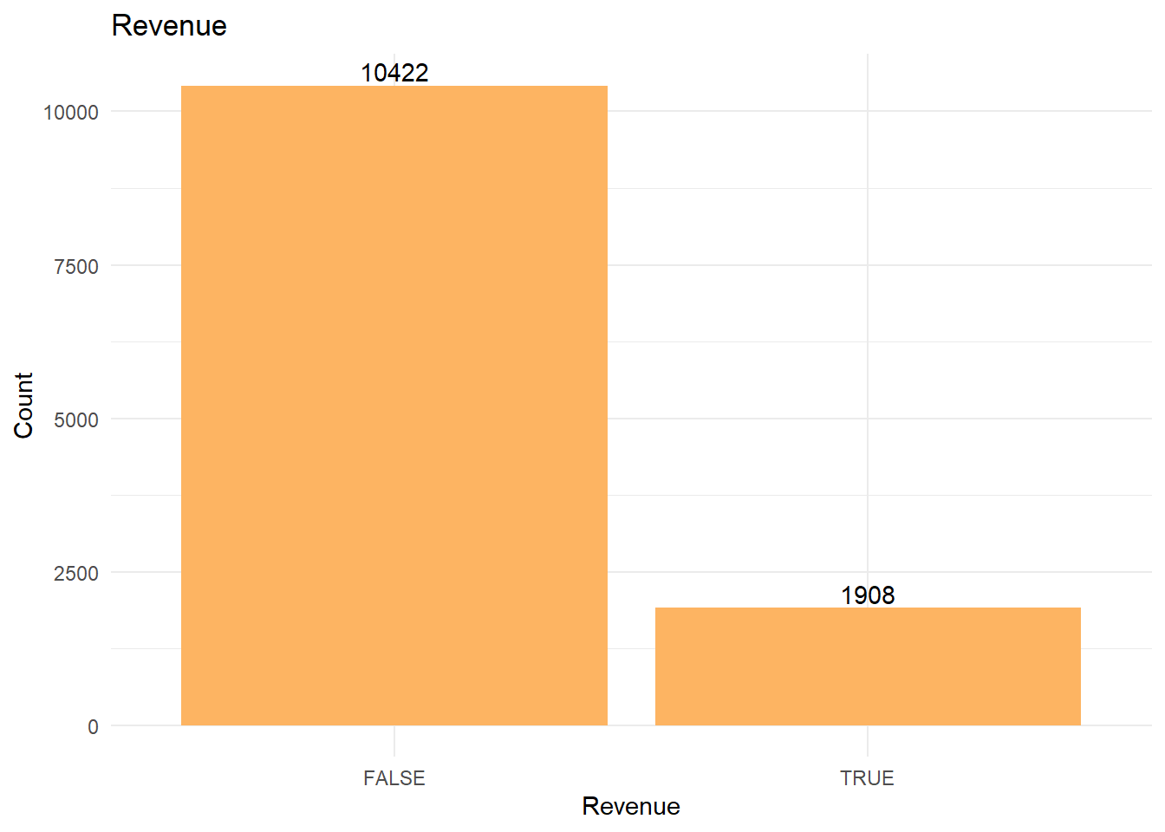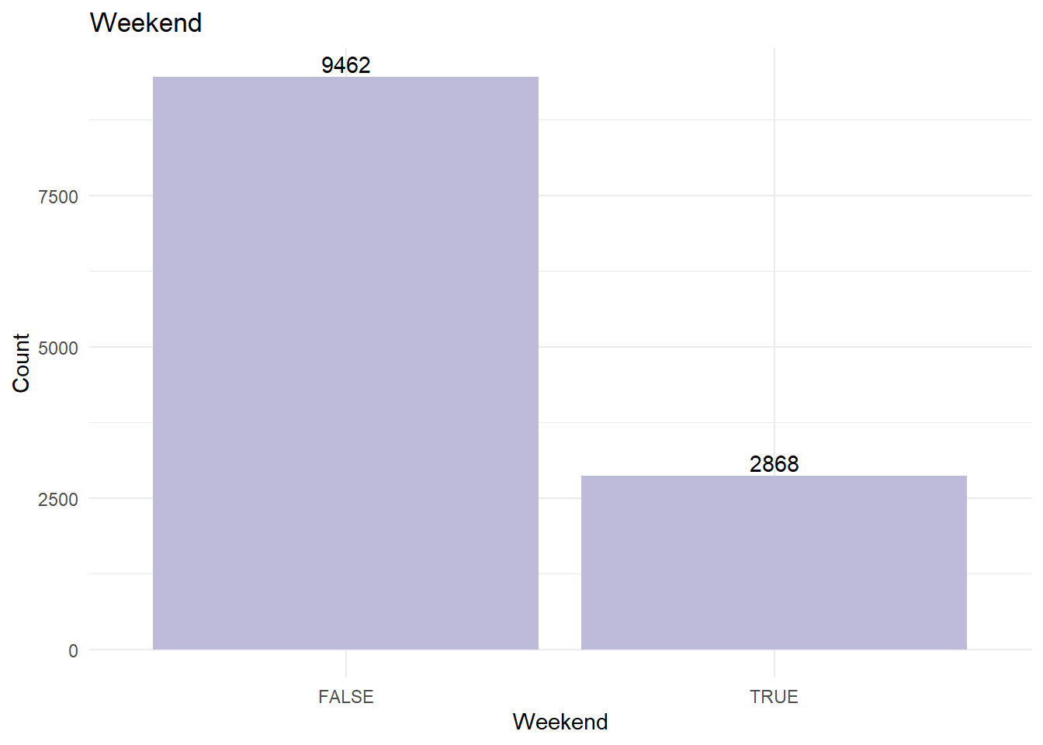

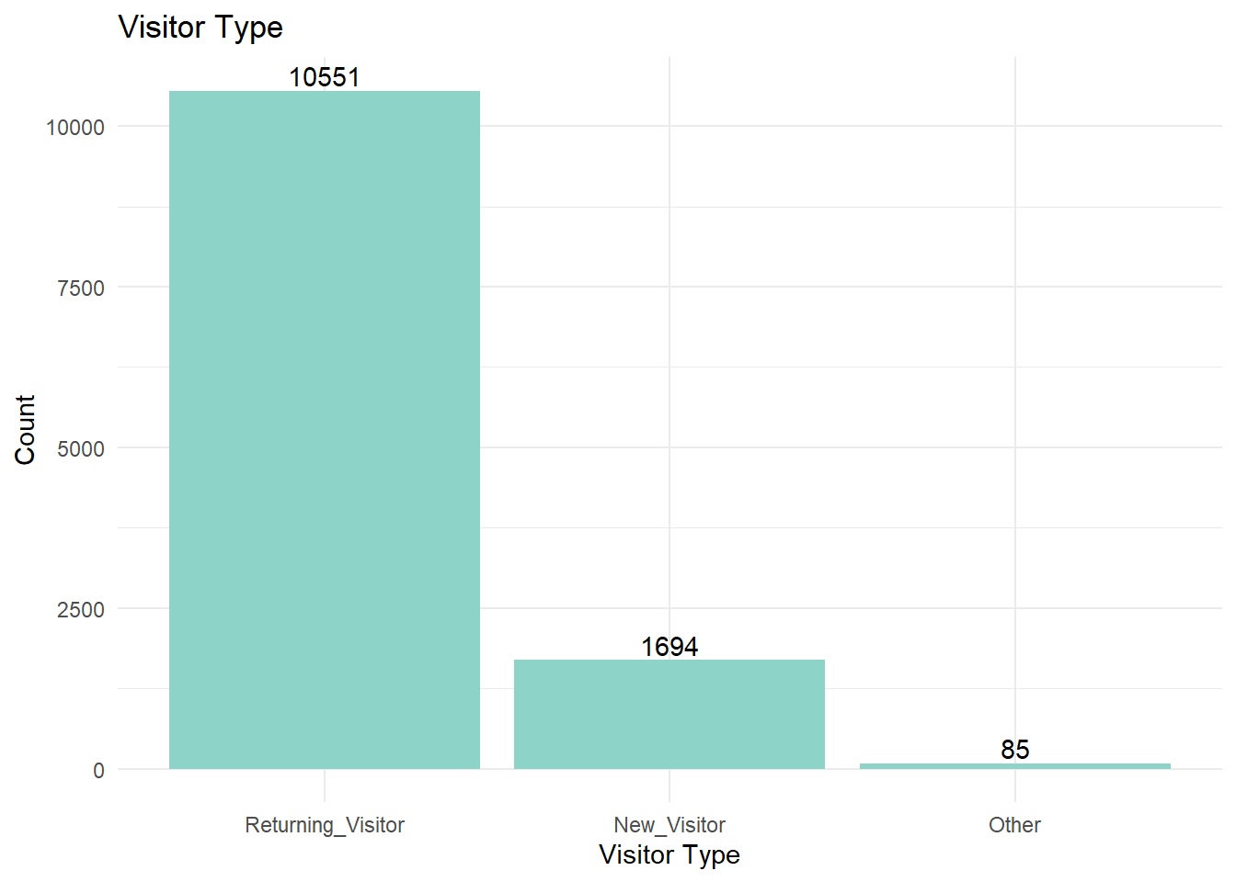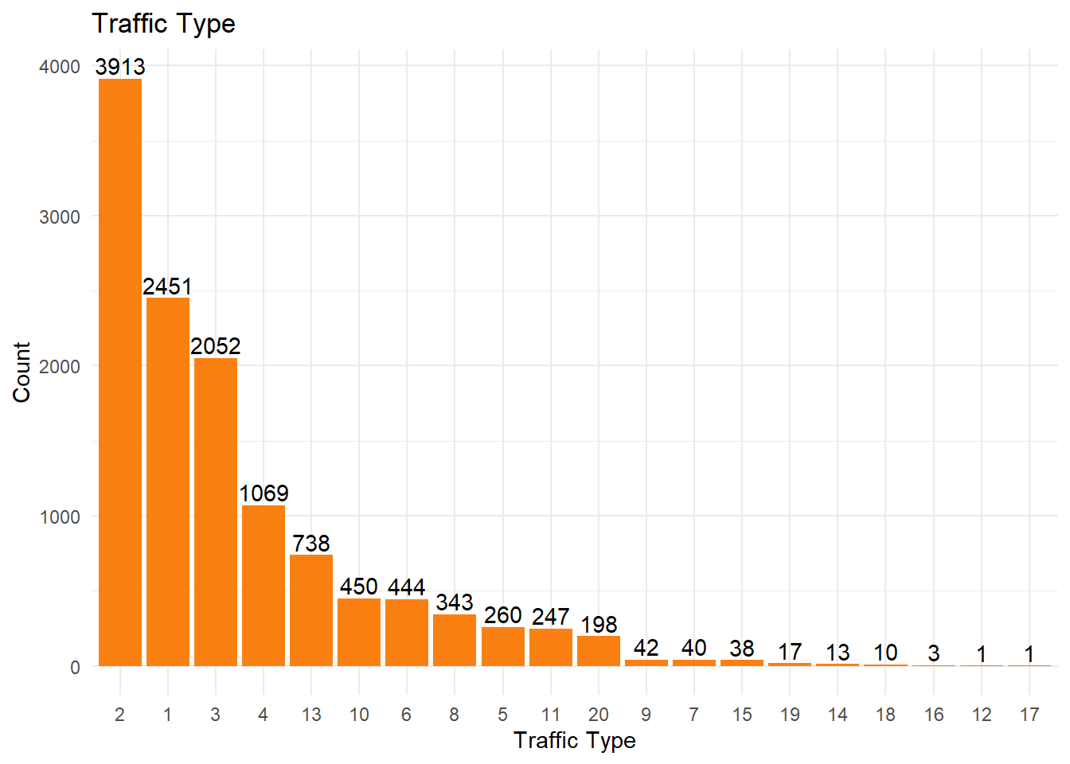

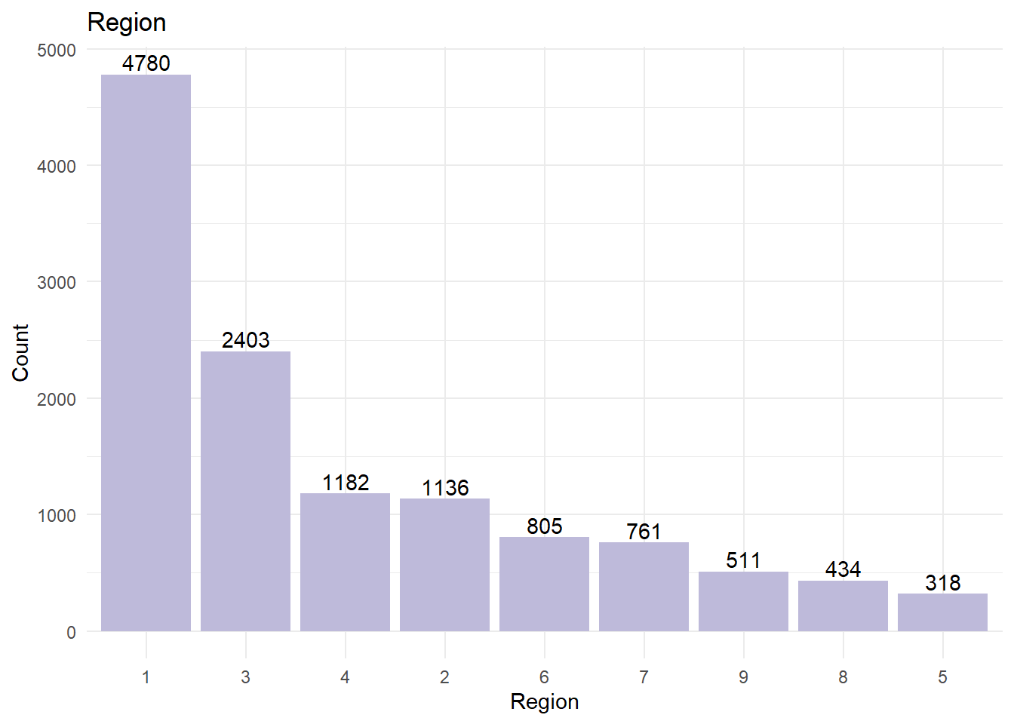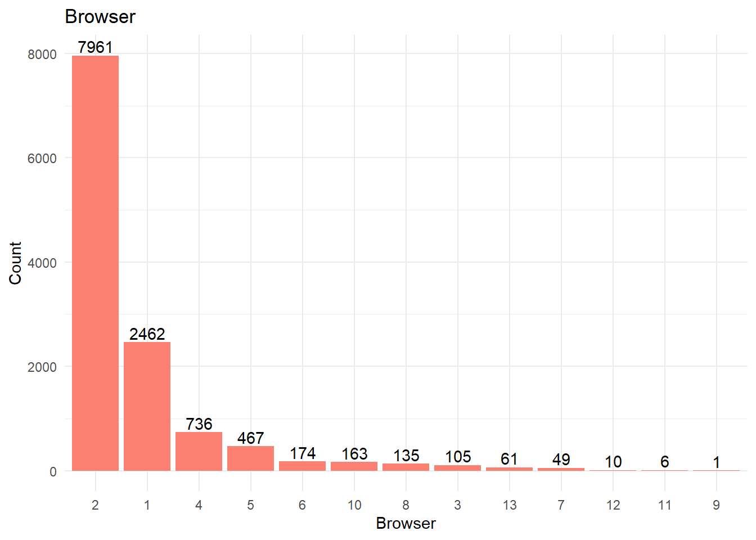

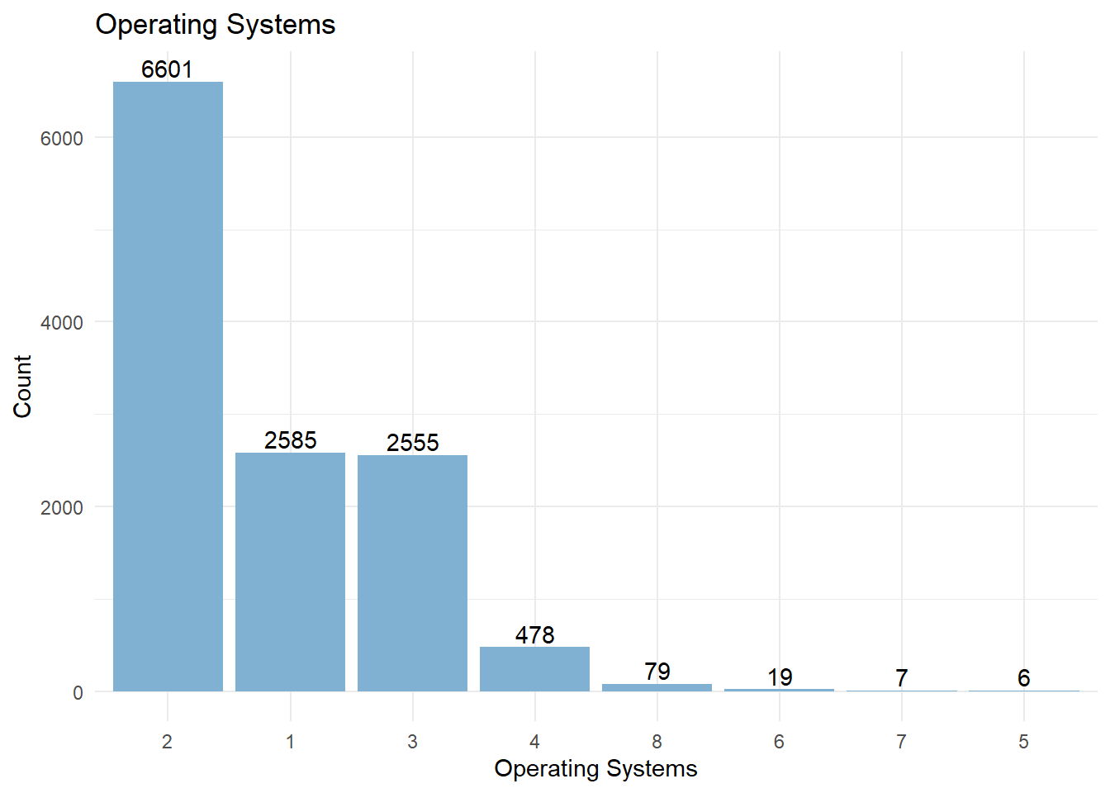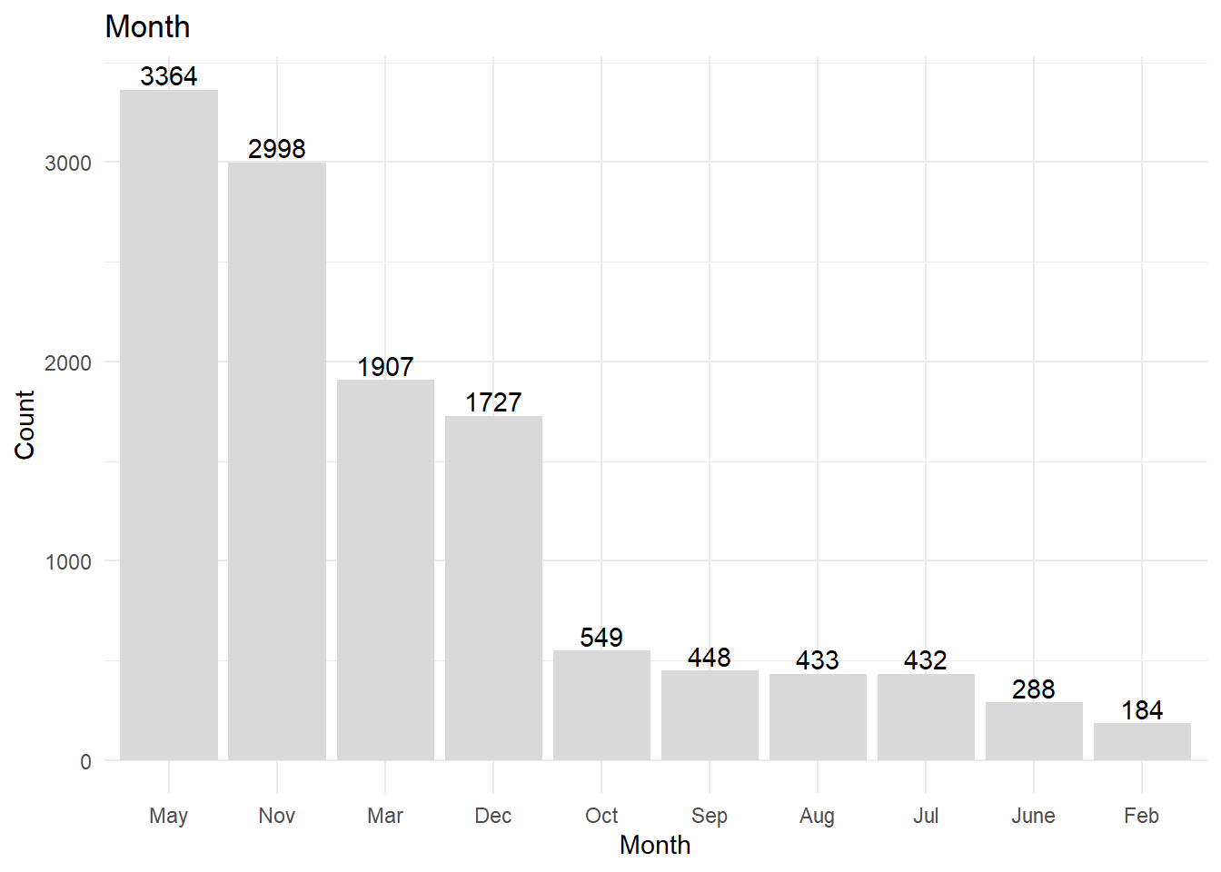

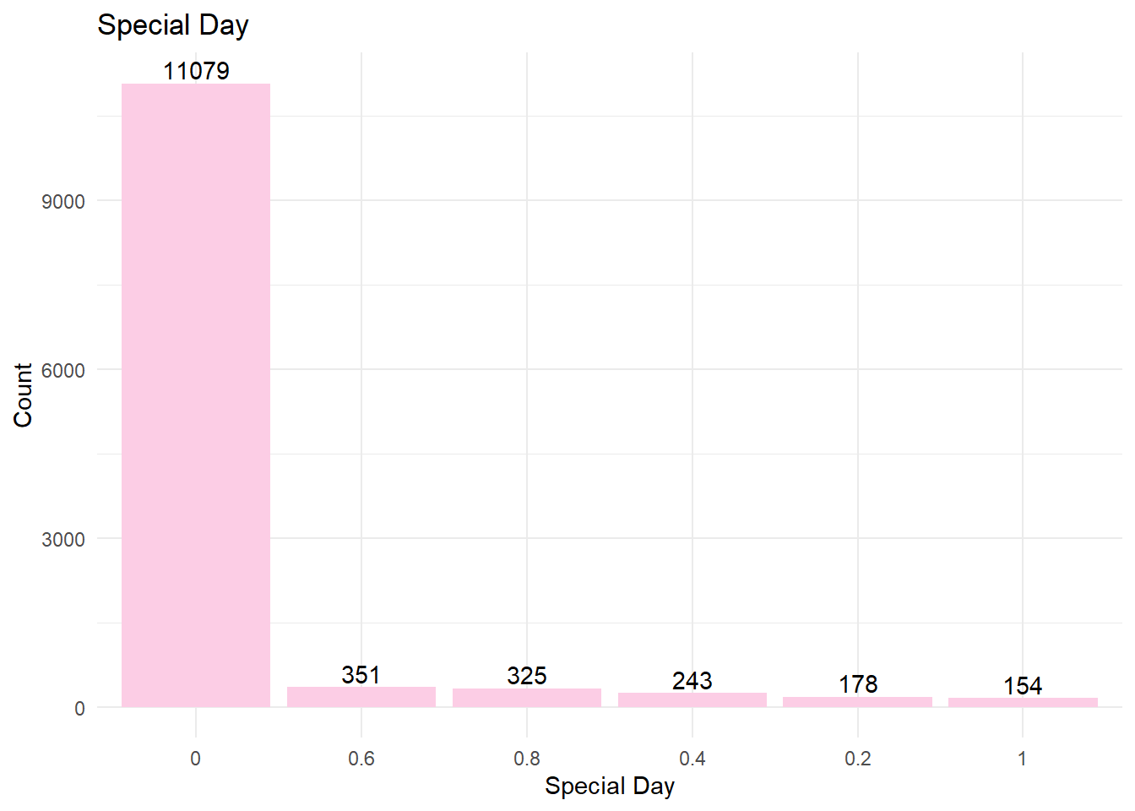

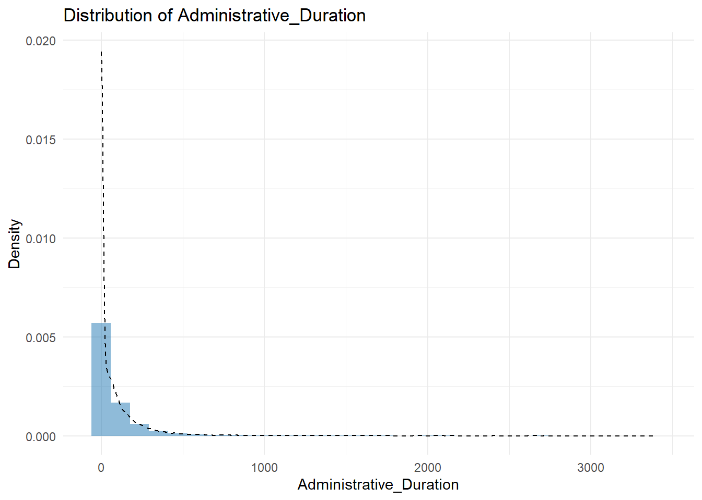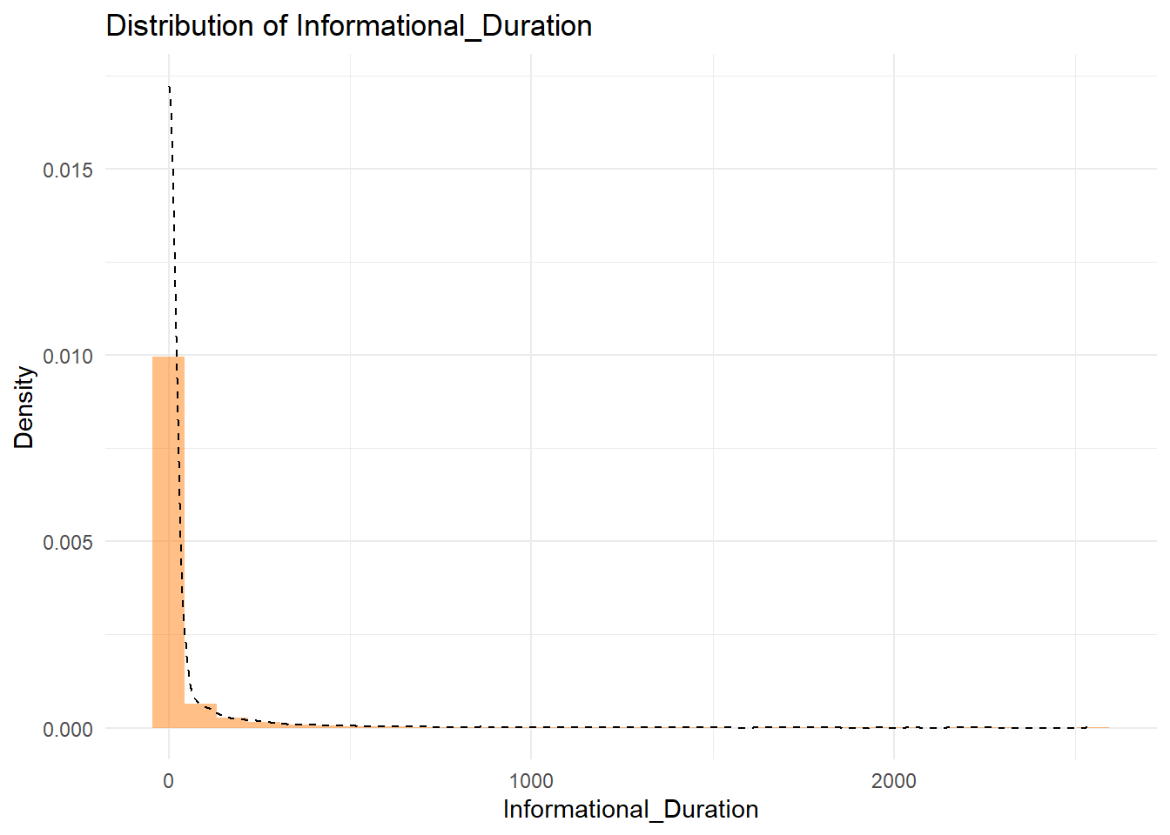

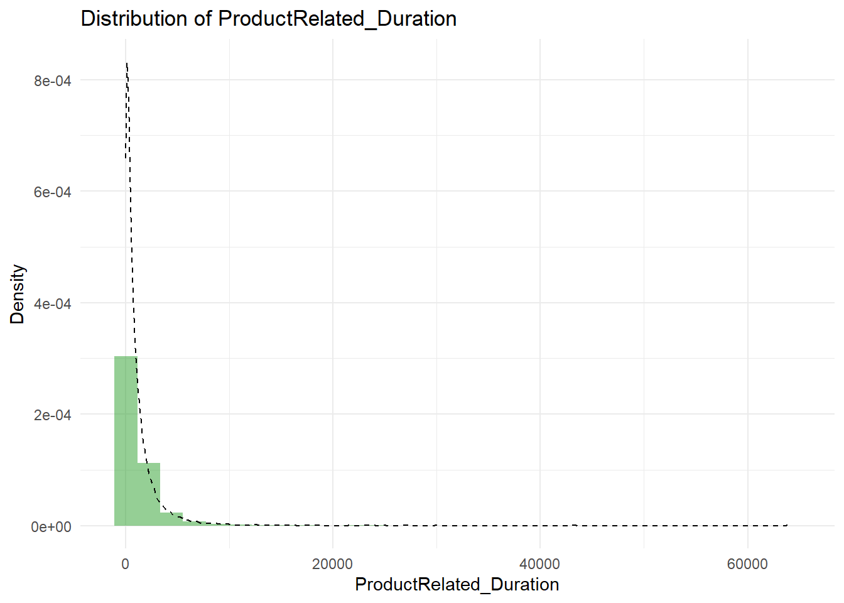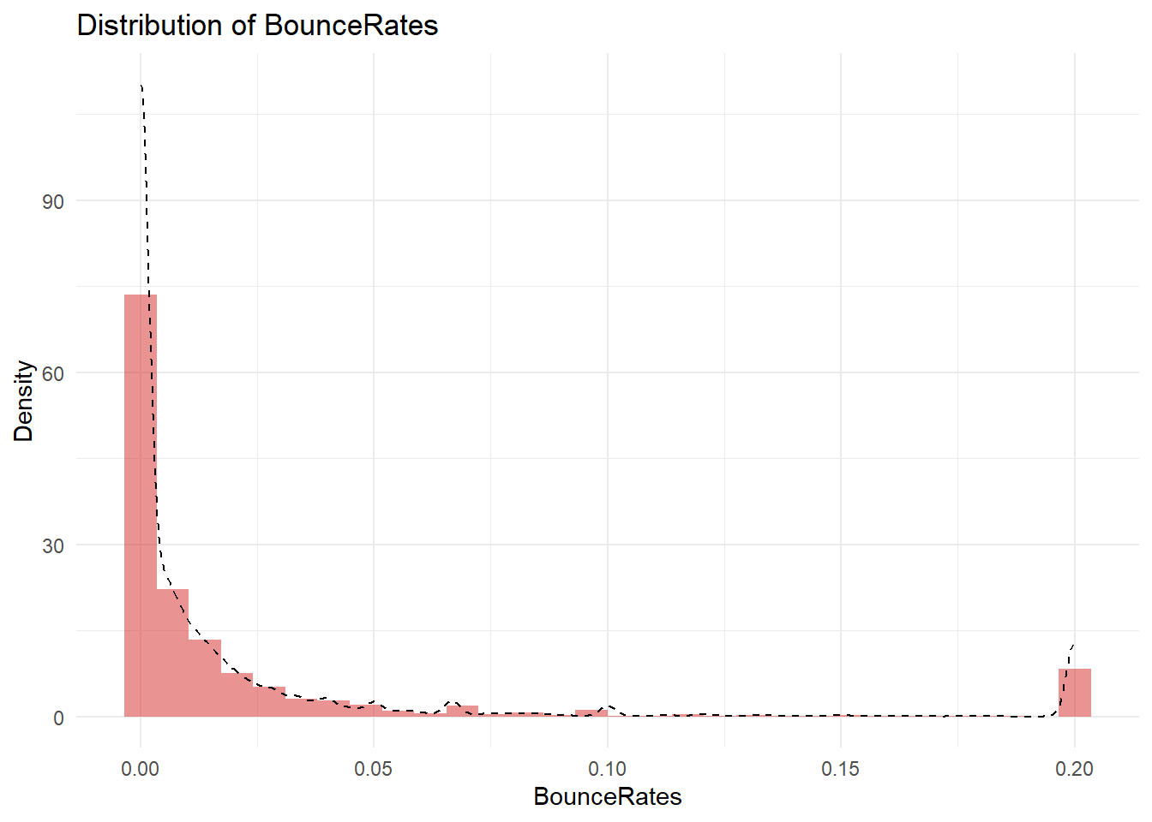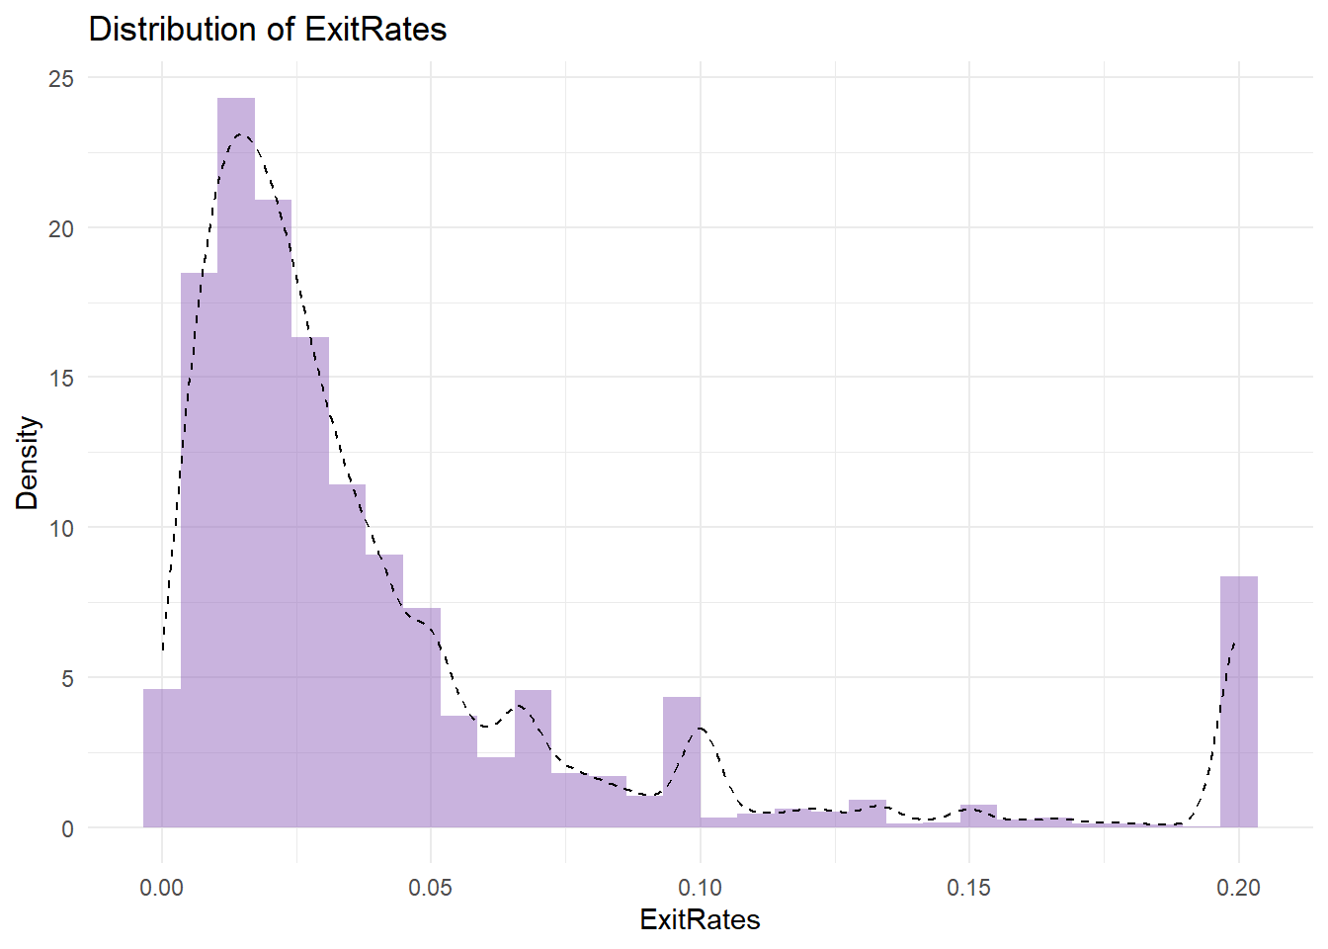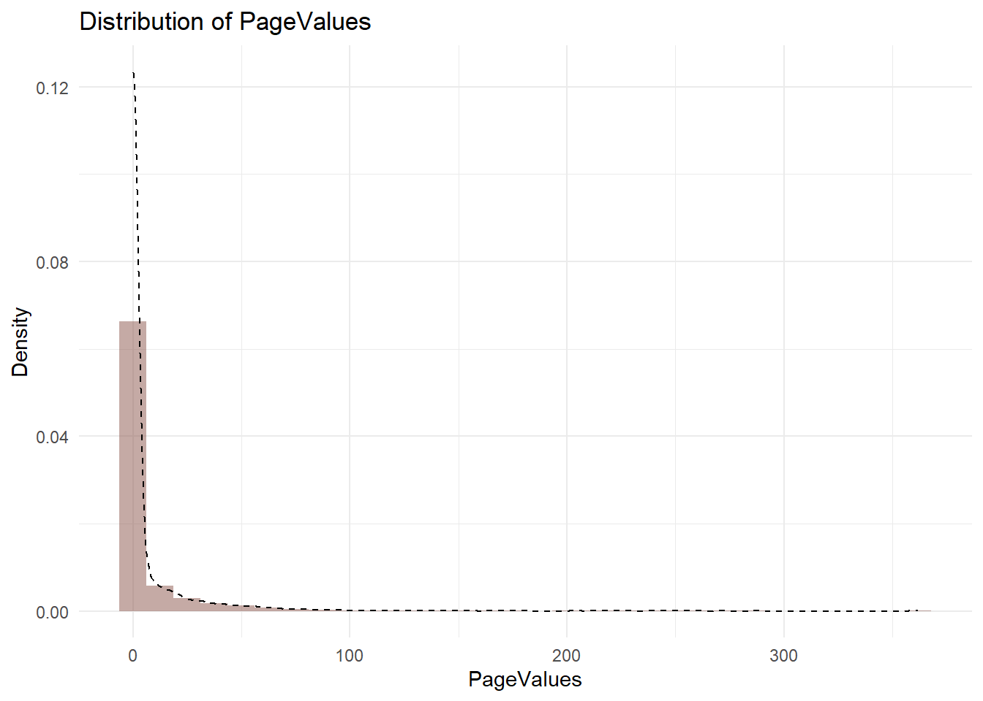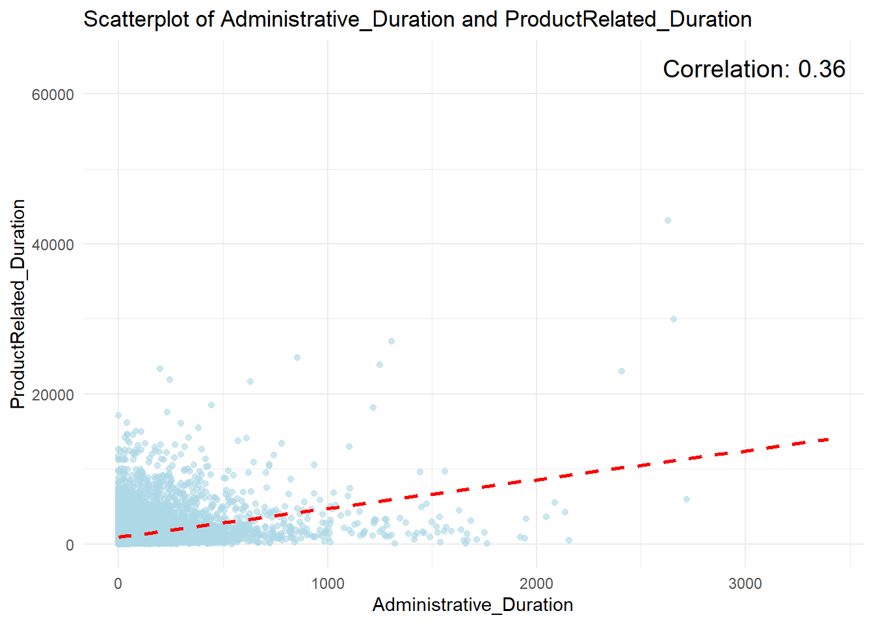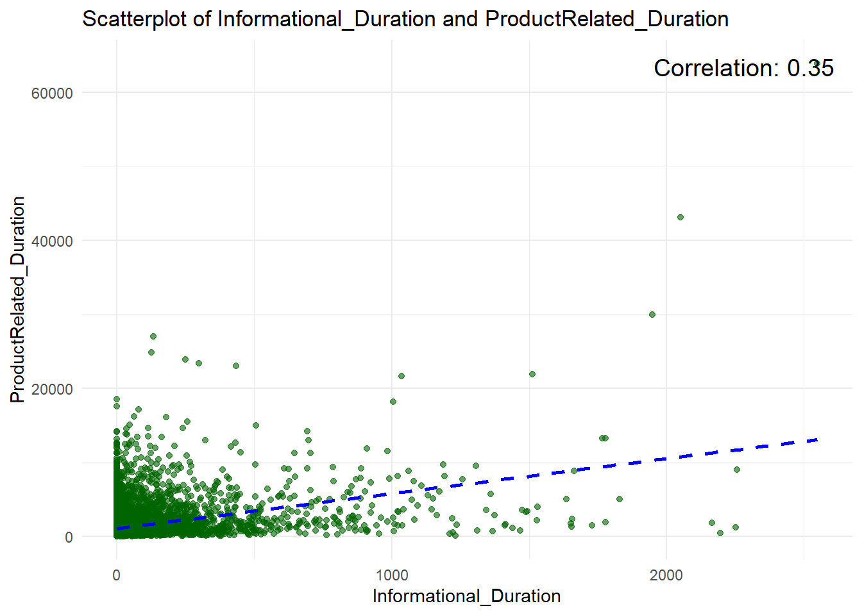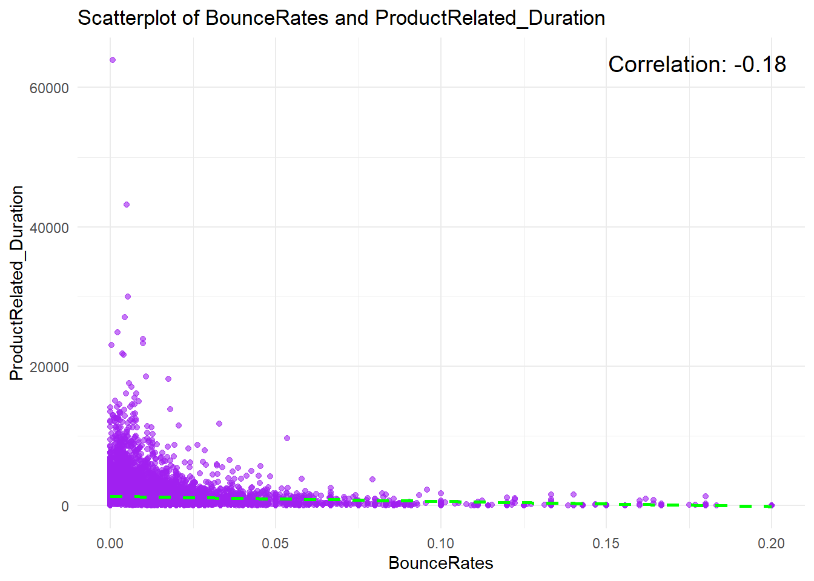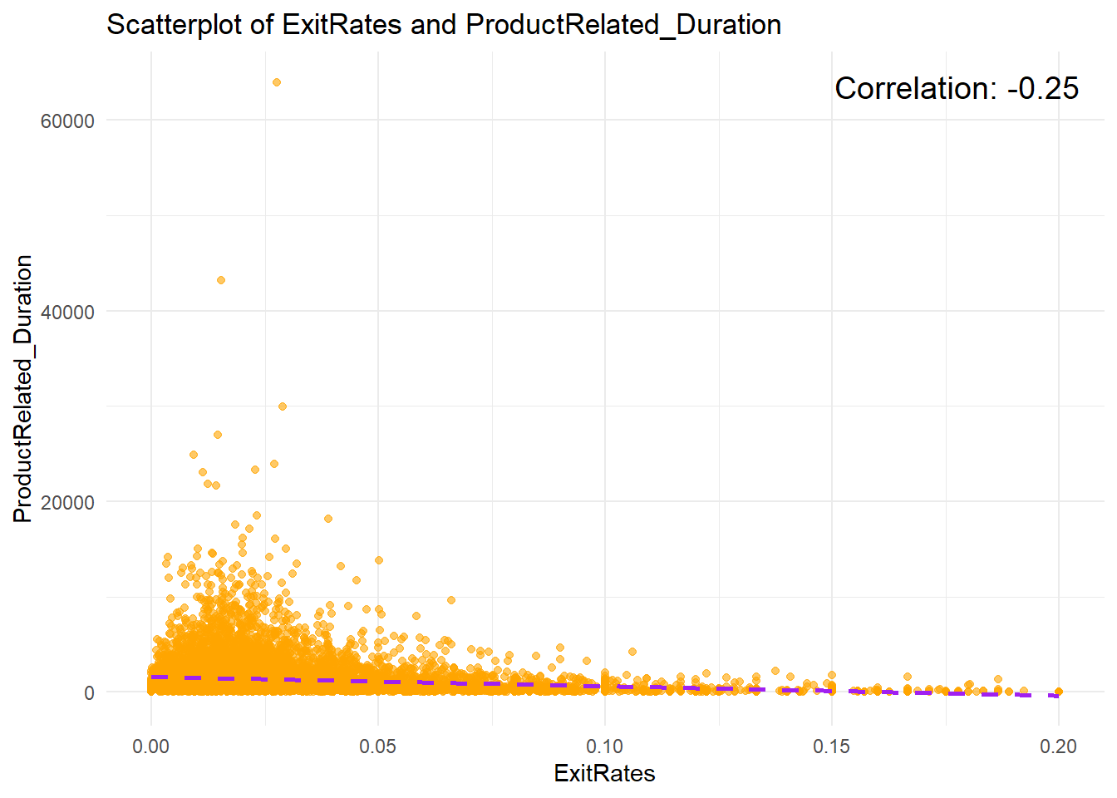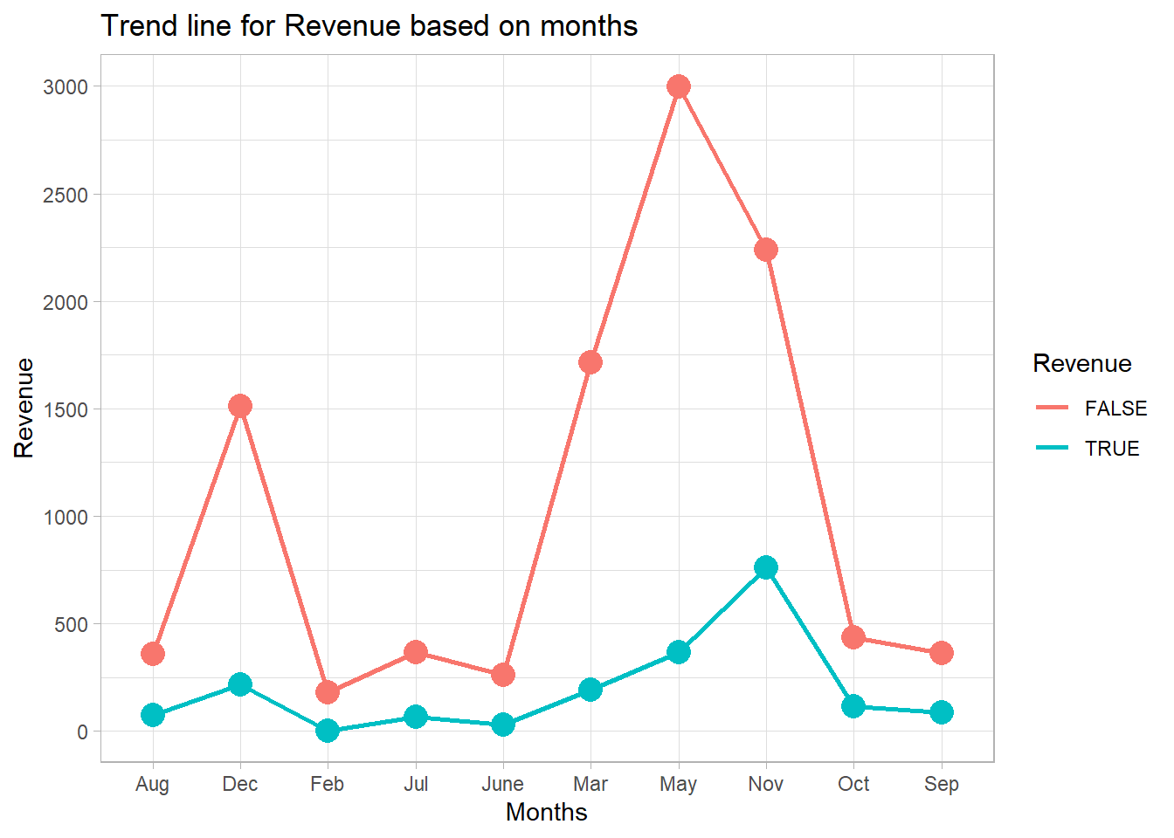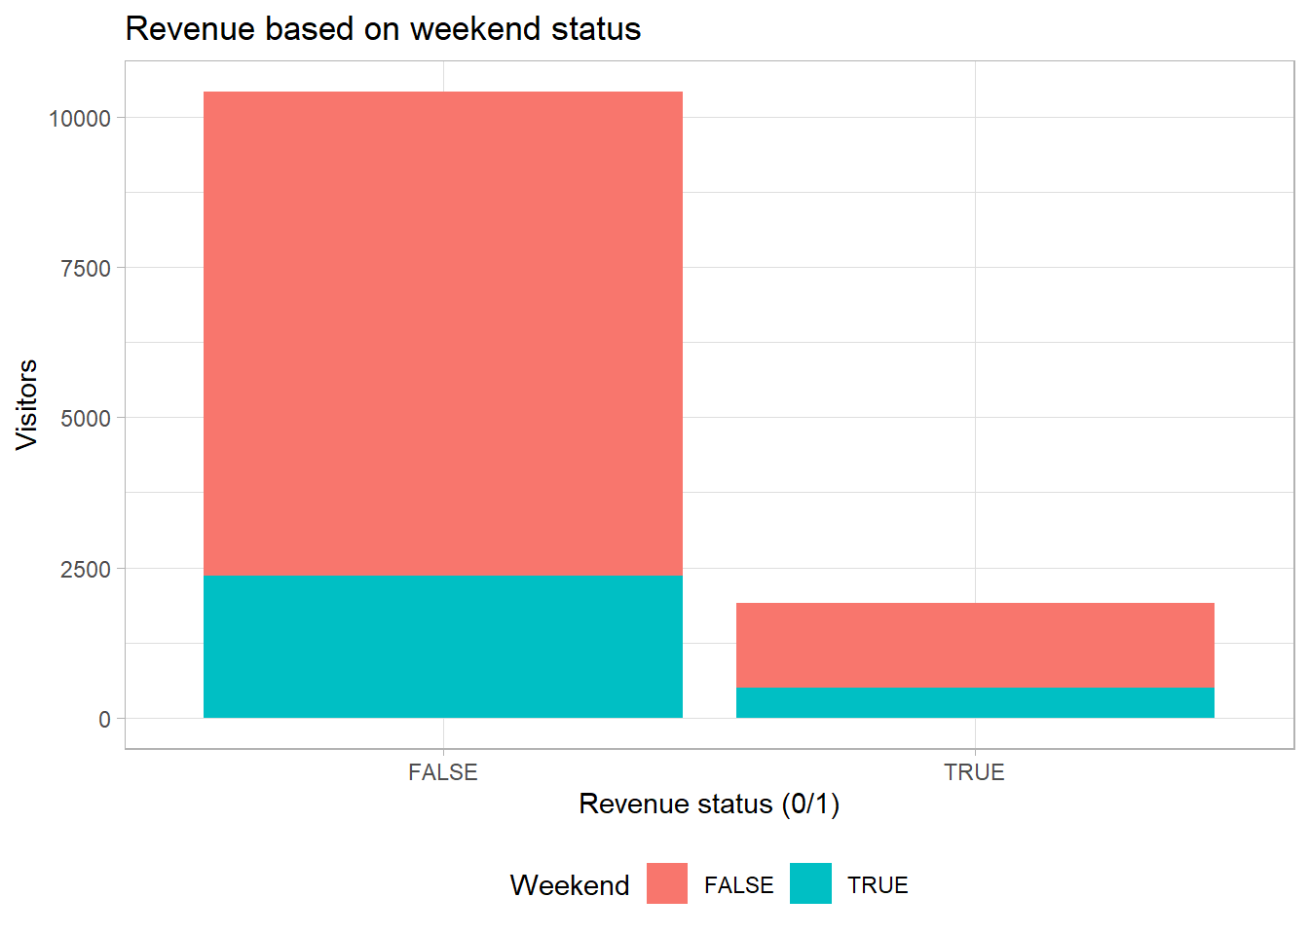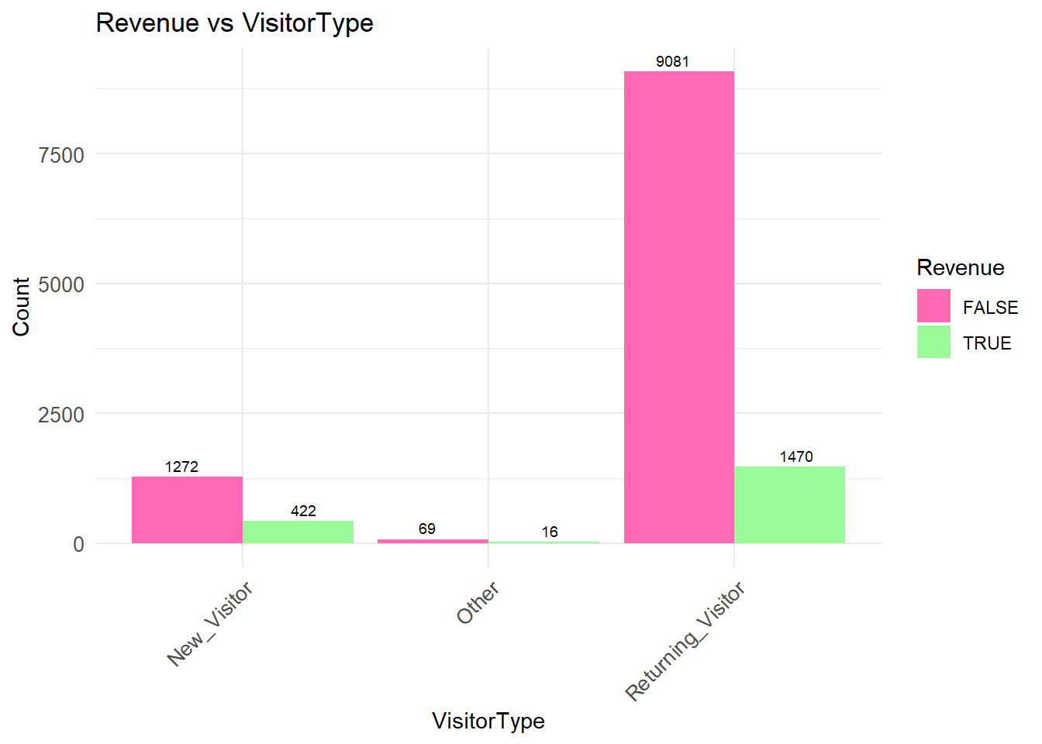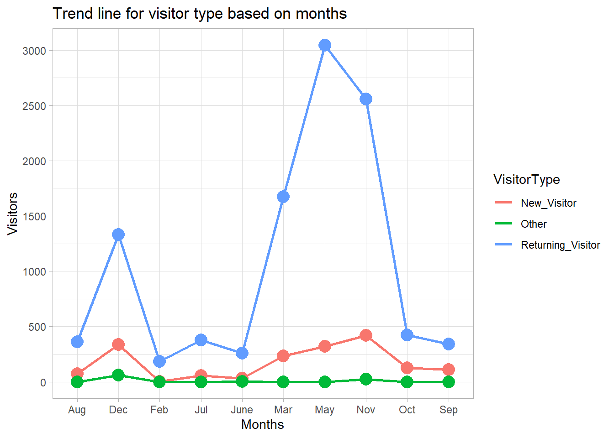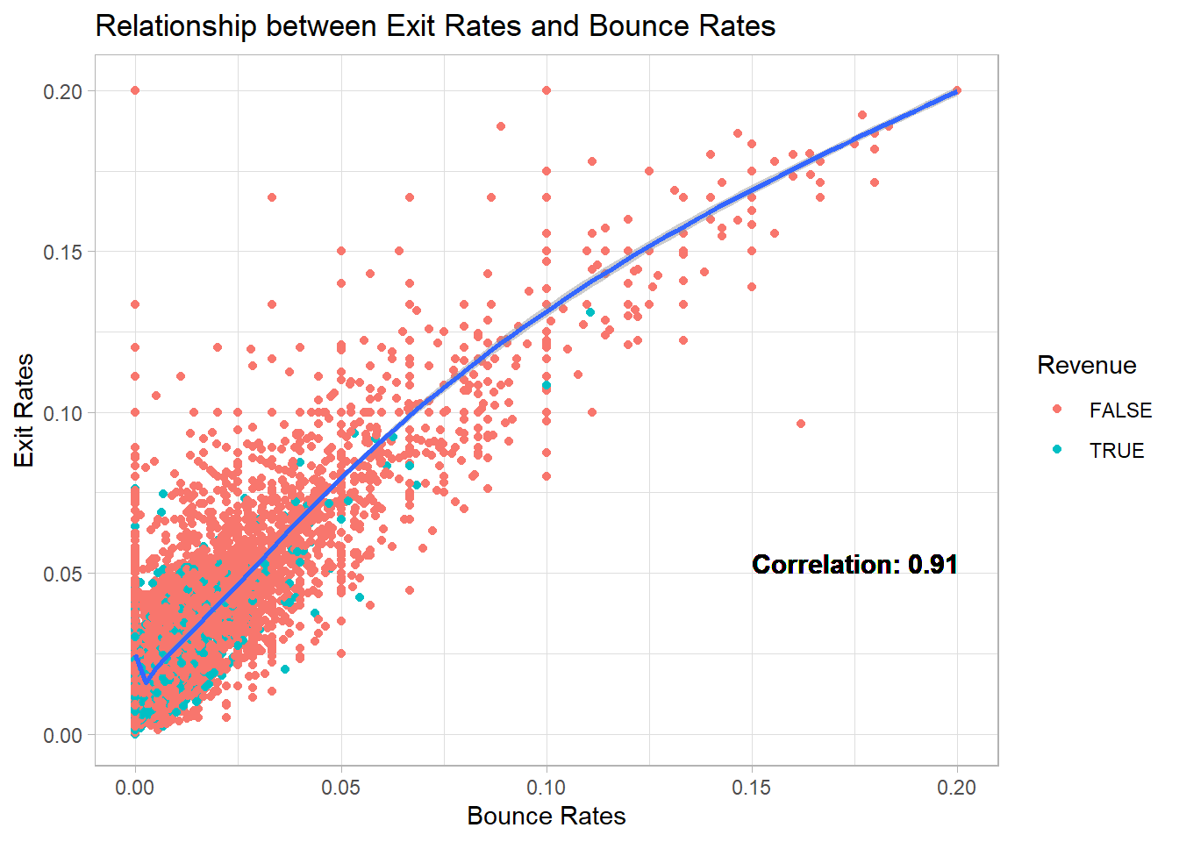

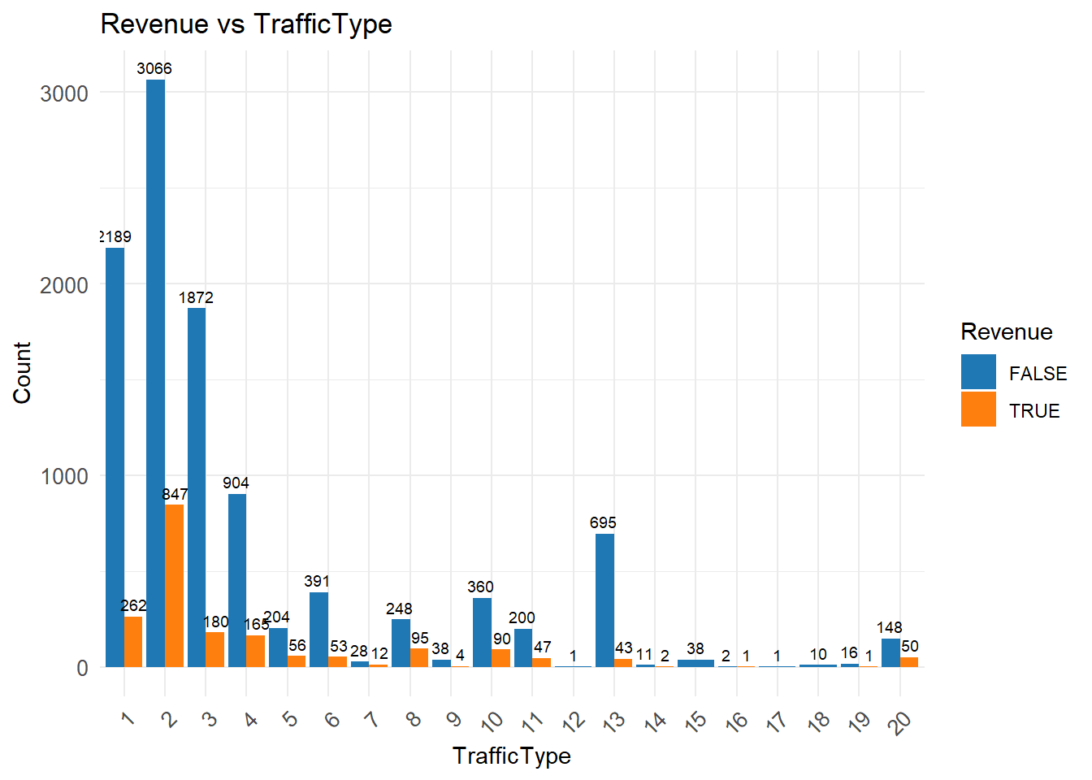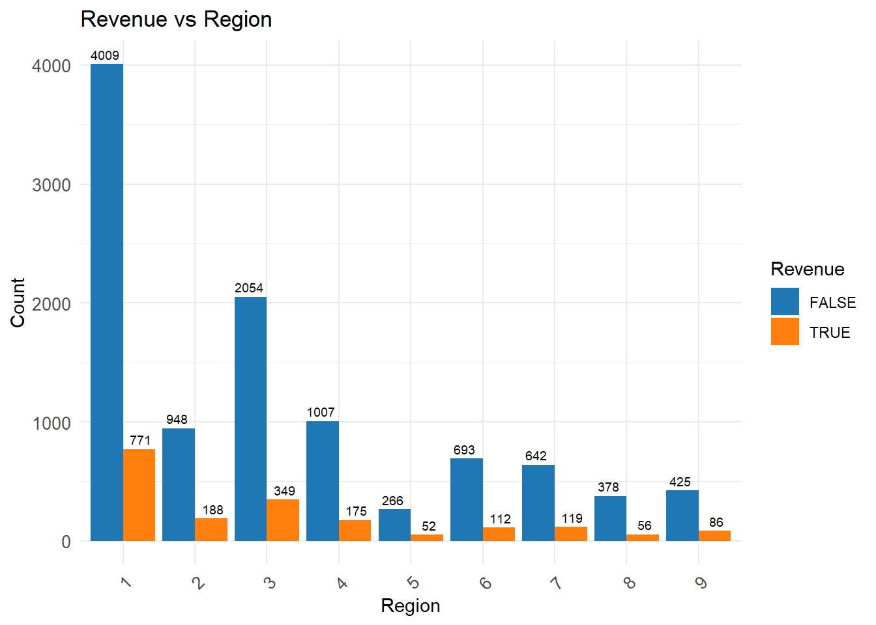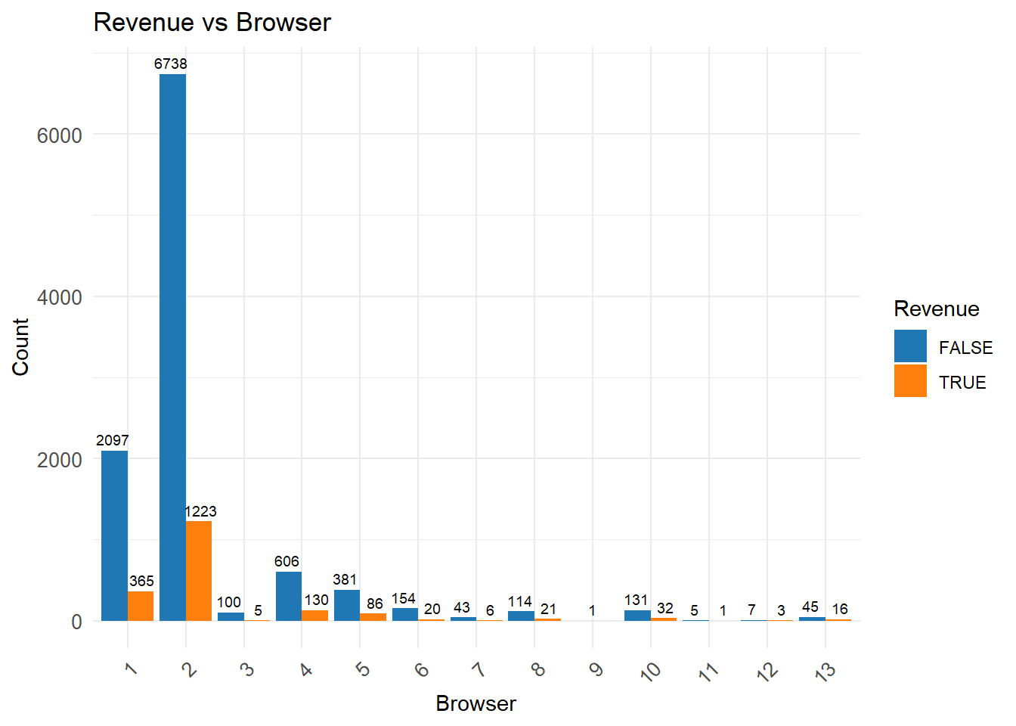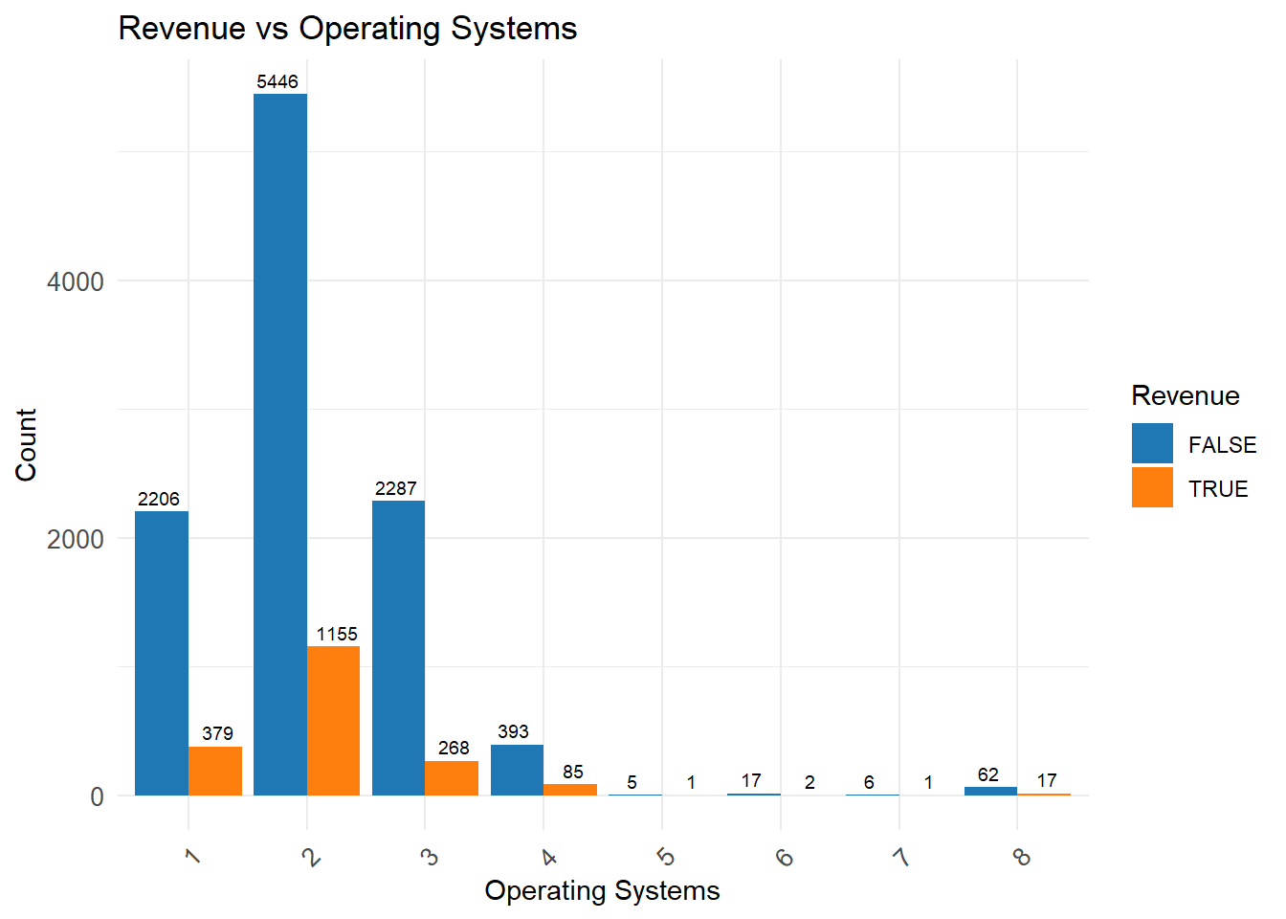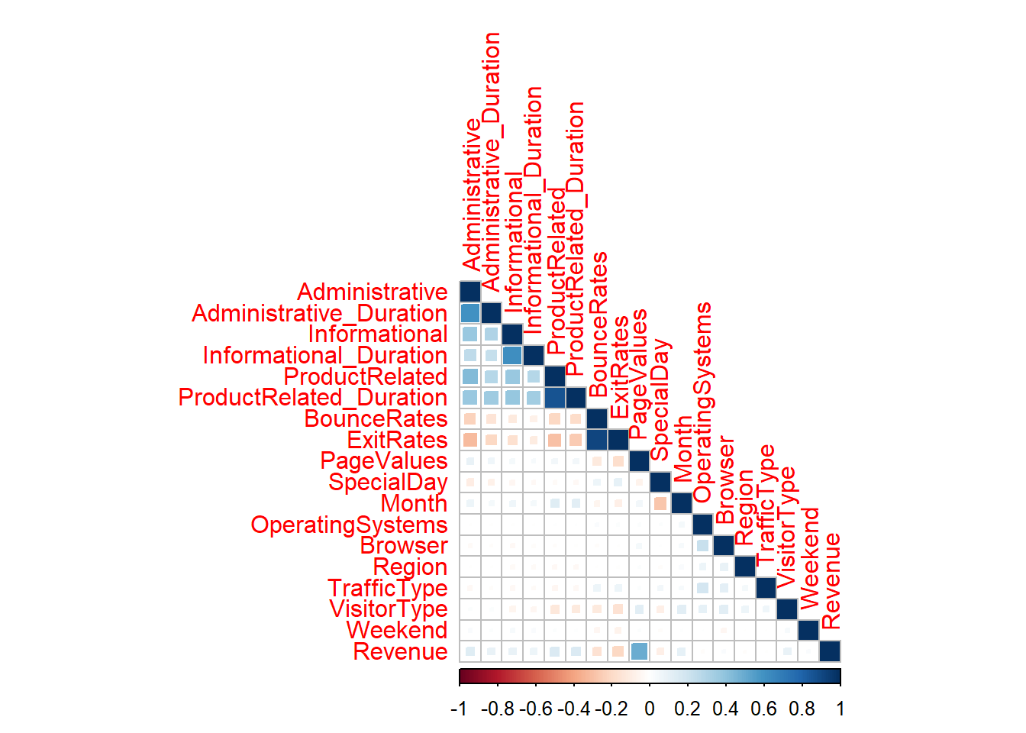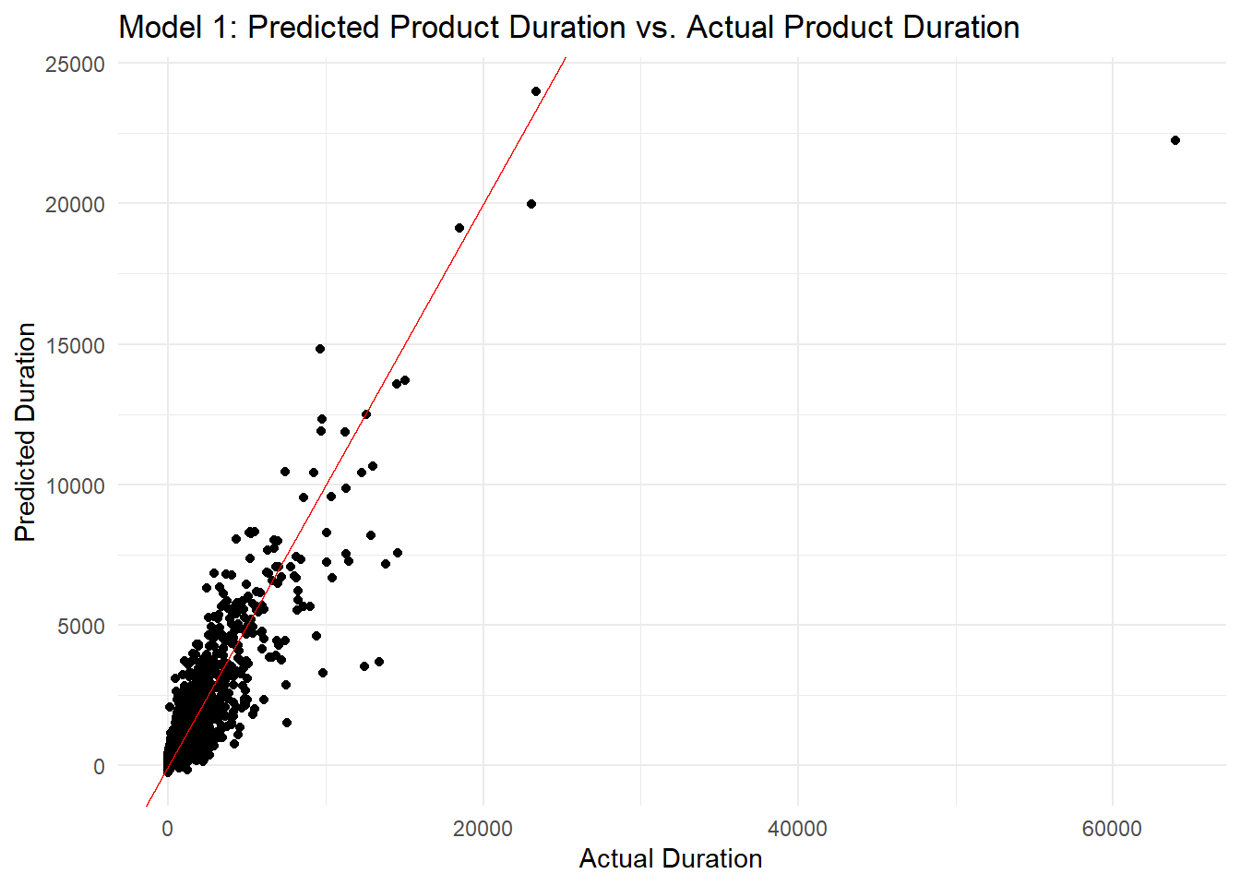

2. Code Snippets and Technical Details:

* Code snippets of the data preprocessing steps, including handling missing values, outliers, and encoding categorical variables. These snippets can assist in replicating the data cleaning process.
* Code snippets showcasing the implementation of various statistical tests used in hypothesis testing, such as t-tests, chi-square tests, ANOVA, and Pearson correlation tests. These snippets can provide a reference for conducting similar tests on different datasets.
* Technical details explaining the variable selection techniques employed in the linear regression model, such as stepwise regression, LASSO, or ridge regression. These details can aid in understanding the process of identifying the most influential factors for predicting customer engagement.

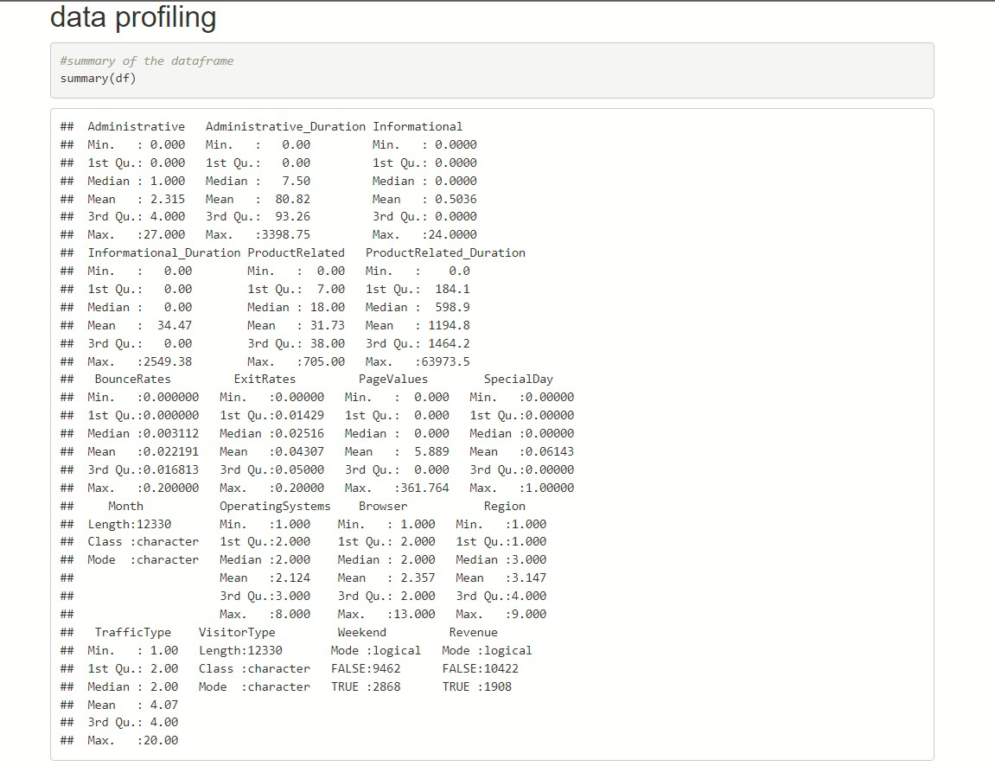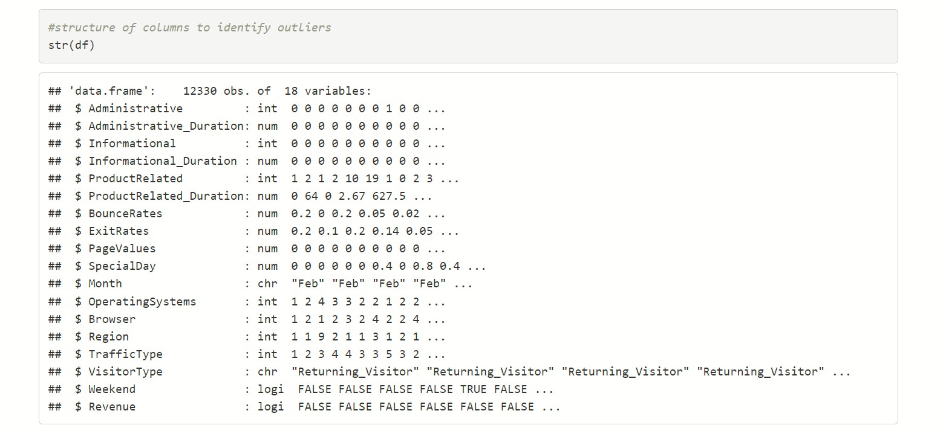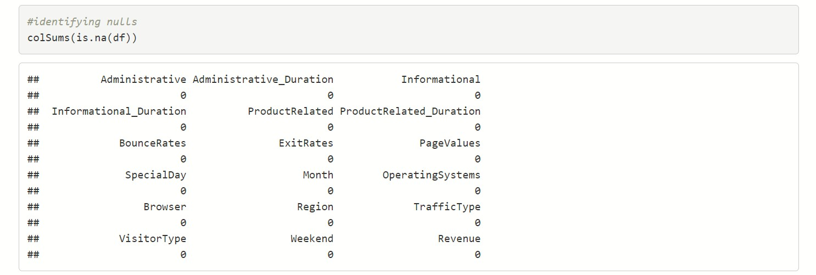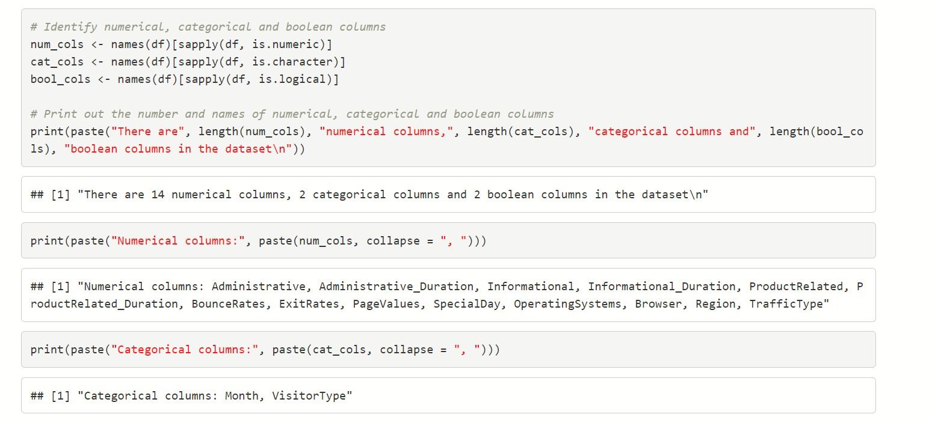

For the exploratory data analysis part the plots are present in the plots section of the appendix.

Below are the codes for the Implementation of Hypothesis testing and Linear Regression and the results generated by them.

